**FORMAT CODE CÁC CÂU HỎI ĐỀ KIỂM TRA GIỮA KỲ**

**ĐỀ PYTHON PROGRAMMING ỨNG DỤNG**

**Câu 1.**

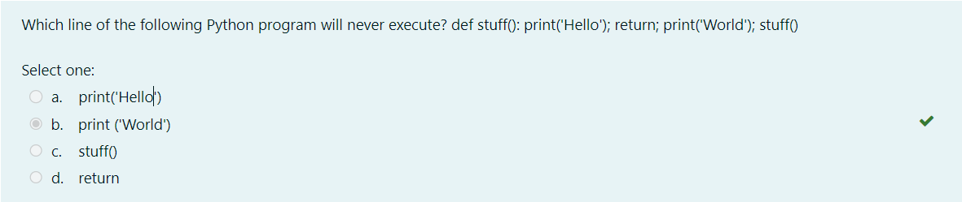

**Code:**

def stuff():

    print('Hello');

    return;

print('World');

stuff()

**Câu 2.**

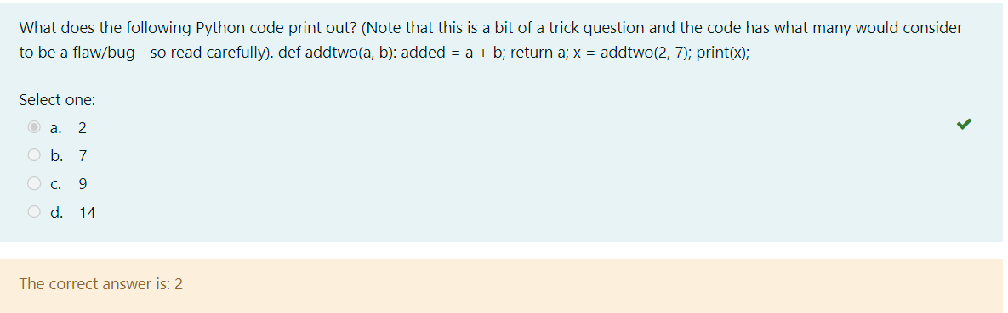

def addtwo(*a*, *b*):

    added = *a* + *b*;

    return *a*;

x = addtwo(2, 7);

print(x)*;*

**Câu 3.**

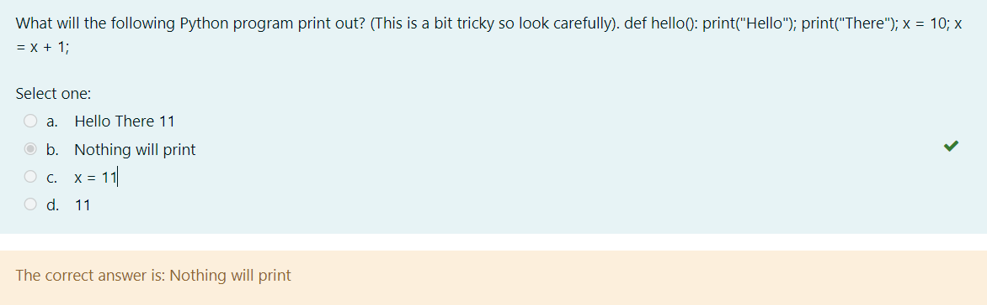

def hello():

    print("Hello");

    print("There");

x = 10;

x = x + 1*;*

**Câu 4.**

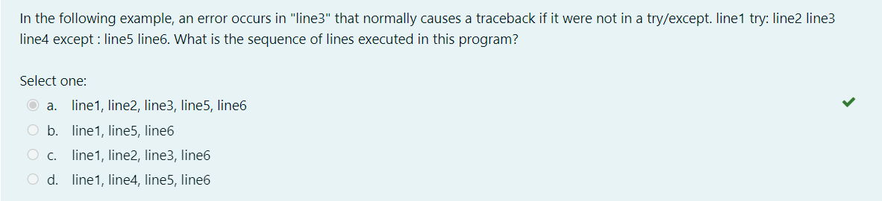

line 1

try:

    line 2

    line 3

except:

    line 4

    line 5

    line 6

**Câu 5.**

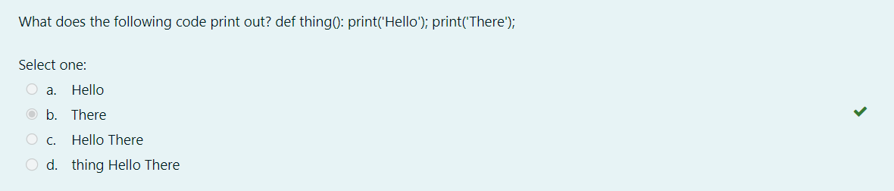

def thing():

    print('Hello');

print('There')*;*

**Câu 6.**

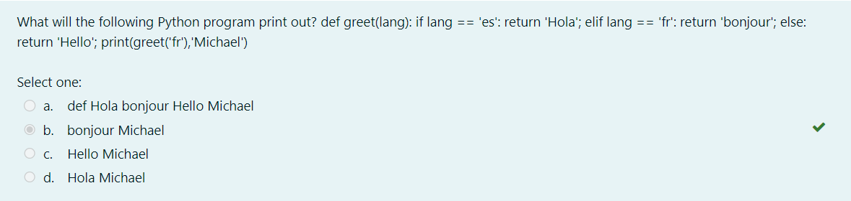

def greet(*lang*):

    if *lang* == 'es':

        return 'Hola'

    elif *lang* == 'fr':

        return 'Bonjour'

    else:

        return 'Hello'

print(greet('fr'),'Michael')

**Câu 7.**

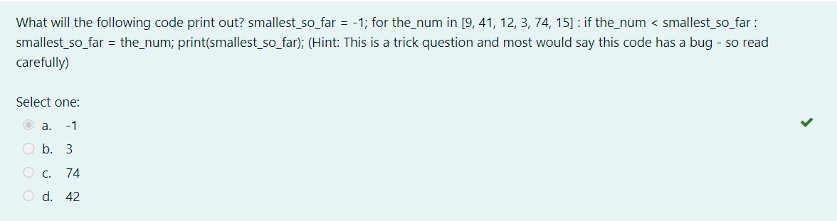

smallest_so_far = -1;

for the_num in [9, 41, 12, 3, 74, 15] :

    if the_num < smallest_so_far :

        smallest_so_far = the_num*;*

print(smallest_so_far);

**Câu 8.**

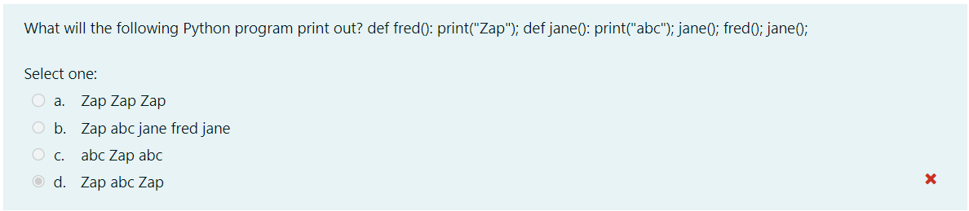

smallest_so_far = -1;

for the_num in [9, 41, 12, 3, 74, 15] :

    if the_num < smallest_so_far :

        smallest_so_far = the_num*;*

print(smallest_so_far);